Digital Assessments for Digital Technologies

There are many great ways to capture and monitor student learning and achievement digitally. In this example, we use SeeSaw as a platform example, however, this could be done with other digital devices (tablets, cameras and microphones) and software, such as Explain Everything, Presentation Software, Paint, Book Creators (ebooks), and even Scratch (MIT) animations.

What are you trying to measure?
When designing digital assessment activities, we want to consider what we are asking students to demonstrate. For example, are students being asked to “describe”, “identify”, “list”, “explain” or something else? To help you generate ways of using digital tools, we have generated a list of example features and aligned them with active verbs that might be present in the achievement standards.

Feature | Measurement goals
Draw/Paint | Identify (circle, mark, underline), describe (write), show (flow, sequence, location), list, model (mind map)...
Label (text) | Identify, describe, recall, list...
Image | Identify (take photo), show, find (take photo)...
Video | Show, demonstrate, identify...
Audio | Explain, reflect, self-assess, peer-assess, evaluate, describe, recall...
Animation | Explain, describe, recall, model, show, demonstrate...

What are some examples?
Below we have generated some examples at CSER, using the SeeSaw platform as an example.
Page 1 of 3
Title & description | Link | Comments
Share your Arduino Project  - Record a video that demonstrates your Arduino project and your next goals moving forward. | https://app.seesaw.me/pages/shared_activity?share_token=57YedqHsRe2l2HrwDOr6IA&prompt_id=prompt.96781726-27ac-4fec-a6f9-7b1abe5959c8 | Could also be done with other digital projects (e.g. LittleBits, Makey Makey, Micro:bits).
Self-assessment of teamwork  - Record a reflection on how you think your team performed. What worked well? What could be improved? How did you contribute to the team? | https://app.seesaw.me/pages/shared_activity?share_token=G14PYpYSQ06Hdj0gIH_Rrg&prompt_id=prompt.c8398212-bbf8-450e-b2bd-1e9ef9f510e1
Share Your Thinking  - Record a reflection on what you just learned. | https://app.seesaw.me/pages/shared_activity?share_token=GWoOlpHLRkem8SkYP4BACA&prompt_id=prompt.314a4946-725f-48a6-886e-7347d72a6d27 | This could be designed as a general question, or to acquire a student’s thoughts about a particular topic or content.
What is a BeeBot?  - Add words to describe a photo of a Bee-Bot. Use the microphone to explain how a Bee-Bot works. | https://app.seesaw.me/pages/shared_activity?share_token=0hY11uwwRzWZ6PXUiiHIaA&prompt_id=prompt.b6f652b2-eb8d-494a-8447-90c9feacbe76 | This could be done for any digital device or technology (e.g. other robots, or a Makey Makey system).
Peripheral Devices  - Label all the peripheral devices you can see in the image and identify if they are input or output devices. | https://app.seesaw.me/pages/shared_activity?share_token=Bk5rRYLETVSZOO6EUCeLOg&prompt_id=prompt.fe1f35ae-9db0-4233-816e-6852460ab335 | Alternatively, students could take photos of peripheral devices they see, label as input/output and upload.

In the following table, we have curated some examples shared on the SeeSaw Community (please see the original author names in the image below). You can see ways in which teachers are assessing various Digital Technologies topics (such as algorithm design, code comprehension, use of surveys and describing experiments). You can search for more examples within the “Computer Science” subject tab on SeeSaw.
Page 2 of 3
Title | Link
Survey Your Classmates | https://app.seesaw.me/pages/shared_activity?share_token=6COUqQuMRI6SOb8sK0WLuA&prompt_id=prompt.d0d559c9-6391-46aa-ac36-6dc6ffc76cb9
Binary Bracelet | https://app.seesaw.me/pages/shared_activity?share_token=YGYsR7VCQUyxLjpGluct6A&prompt_id=prompt.b44b3b84-939a-4a56-9c21-fec7cd4039af
Code.org Puzzle | https://app.seesaw.me/pages/shared_activity?share_token=5yGCh9OLTtmOyxxaKBmZeQ&prompt_id=prompt.b0717c38-17a2-4b32-b90a-066bb445b23b
4 C’s Reflection | https://app.seesaw.me/pages/shared_activity?share_token=UXNZo6ecSPyCd1Unk6VuZQ&prompt_id=prompt.446c4e6d-63be-4661-b279-ed4b9e8dde88
Activity 4: Capture an Experiment | https://app.seesaw.me/pages/shared_activity?share_token=UEQUV9L0TaC-C2rZK77QLw&prompt_id=prompt.7405c9e0-7e30-4e42-9dd0-3564b0918c2e
Binary Spelling | https://app.seesaw.me/pages/shared_activity?share_token=_Oyl6-l6ROKaCxMwgQx-gw&prompt_id=prompt.eef051f6-8d52-4d0d-81f7-ded361e914ee
Program a Partner | https://app.seesaw.me/pages/shared_activity?share_token=pgr-9YbzRdKTBxd1-sW5tg&prompt_id=prompt.1b78cea2-d8a1-4cde-875f-8cbb7fd1be0a
Lifecycle of a Sunflower Coding | https://app.seesaw.me/pages/shared_activity?share_token=2RAro-PwSiCd_eHIxj2Mmg&prompt_id=prompt.f59fe8d9-3da4-493f-98b1-7302d335cef2

Original authors for above activities
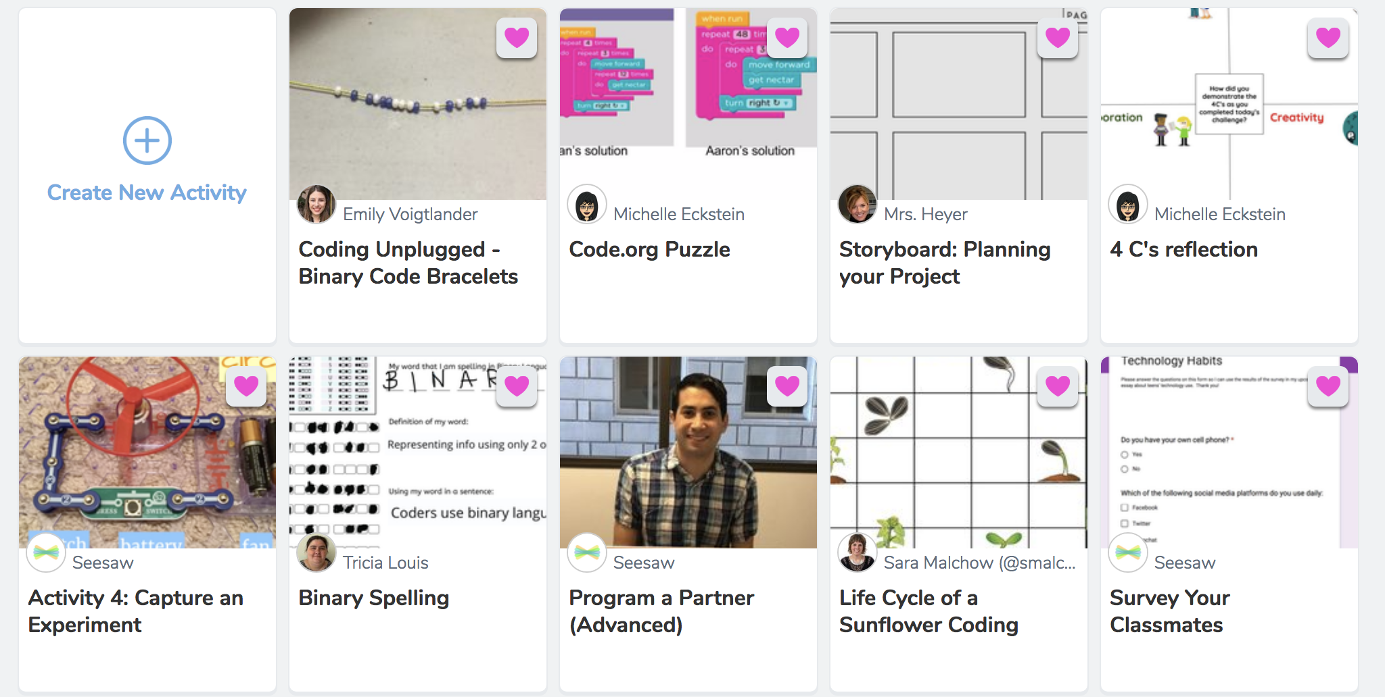
Page 3 of 3

