Variables

Creating Variables
Variables are the very core of any programming language. The commands of the language manipulate the data and this data happens to be stored in these variables.
Naming Variables
There are some rules you have to follow when naming your variables:
All letters and numbers can be used.
You can’t start with a number.
Symbols such as -, /, #, or @ can’t be used.
Spaces can’t be used.
An underscore ( _ ) can be used instead of a space.
Uppercase and lowercase letters are different eg “Dogs” and “dogs” are treated as two different variables.
Don’t use words that are used as commands, such as trace, string etc.
When declaring a variable in ActionScript 3, you must use the keyword var. Right after the var keyword you type the name of the variable you want to use followed by a colon and the type of variable it will be ie String, integer, double etc.
Examples of local variables:
var numApples:int = 4;
var guestName:String = “John”;
var livesLeft:int = 3;

Activity 1:
Add the following code under your trace function.
var myVar:String = “This is my first variable”;
trace(myVar);
Your output should look like the following:
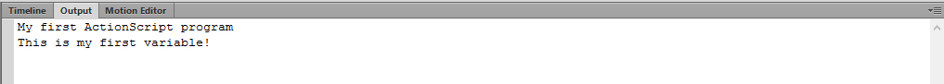

Changing the Contents of a Variable
To change the value of a variable simply assign a new value to it. Here, the variable livesLeft is created and is given the value 3. It changes to 2 when it’s assigned a new value. (Note that you only need to use the var keyword when you are creating a variable for the first time. After that you just refer to it by name).
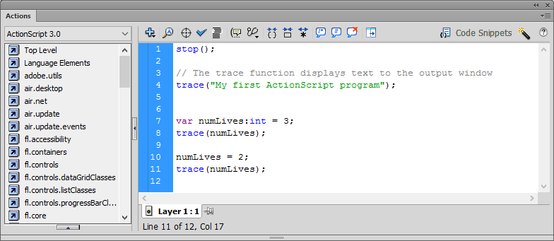

Using Variables
The value of one variable can be assigned to another one using the “=” sign. For example, if the variable “rabbits” contains the number of rabbits, we can use it to assign the same value to the variable “hats”, so that each rabbit has a hat.
Eg: rabbits = 5;
hats = rabbits;

Simple Calculations
You can do simple calculations using numbers as well as variables. The following example simply adds two numbers together and stores the answer in a variable called “total” and then displays the total to the output window.
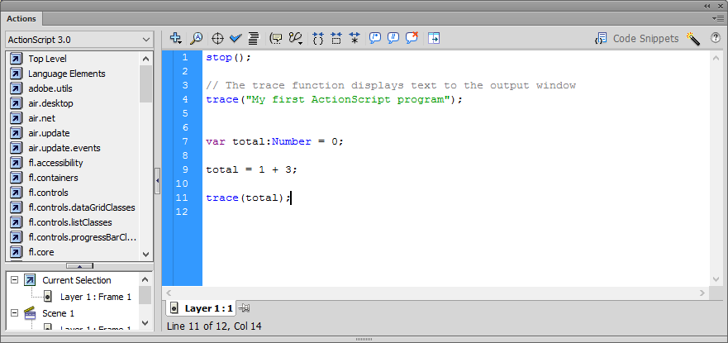
The following Mathematical symbols can be used in Flash:
Addition | +
Subtraction | -
Multiplication | *
Division | /

You can also add variables together (as long as they are of the same type eg you can’t add a string and a number together). The example below adds two integers togethers.
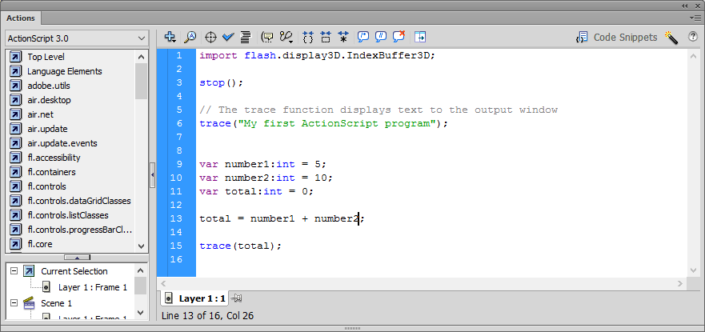

Random Numbers
You can randomly generate a number which is very useful when creating games. You do this by using the Math.random() function which generates a number between 0 and 1.0. So, to get a number between 0 and 10 you would multiply the result by 10 as shown below.
