Can an AI recognise what you are drawing?
Year Band: F-2: DT + The Arts
Please refer to the online lesson plan on the DT Hub to access all website links and additional resources.


Image credit: MabelAmber/pixabay

Summary
This lesson provides an opportunity to incorporate representation of data using a relevant context being studied in the classroom. Students represent an object using a line drawing, focusing on the features of the object that enable it to be easily recognised. Students experiment with creating representations using an AI drawing tool that guesses what is being drawn. They record their drawings alongside the AI prediction (drawing) using suitable and familiar software.
This set of lesson ideas was developed in collaboration with the Digital Technologies Institute.

Preliminary notes

Familiarise yourself with the AutoDraw website and launch the experiment. Draw onscreen and see how well the AI guesses what you are drawing. The predictions are shown at the top of the screen next to the prompt ‘Do you mean’.
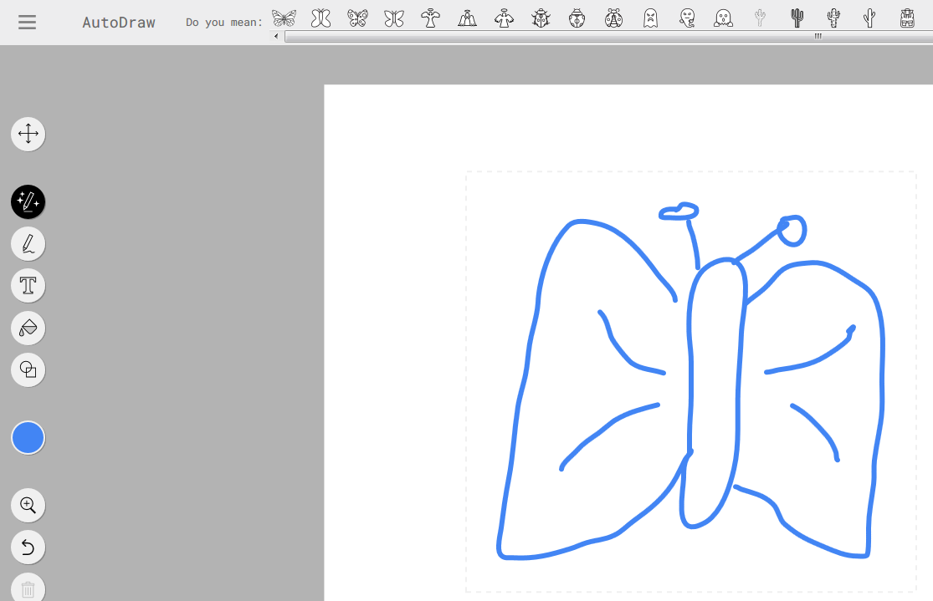
Image credit: AutoDraw interface

Suggested steps
Unplugged activity 1: Signs in the community
- As a starting point, share some images of signs students may see in the community.
It may be possible to share images captured using smartphones of signs in the local community or do a community walk on a hunt for signs.
As an example, ask what this sign is for. Why is it important for people to know what it means? How do we know what it represents?

Image credit: AbsolutVision/pixabay
- Ask a student to draw a representation of a traffic light. What are its features? How is colour often used in this representation? (Note: the AI tools used next in this lesson do not use colour as a means of identifying an object).

Unplugged activity 2: Line drawings to represent an object
- Ask students to think about how they would represent a honey bee as a line drawing.

Model how to draw an object such as a honey bee and discuss the features that would make it easy to recognise as a line drawing. Discuss what it might be confused with; something that has similar features when drawn, for example, a fly. (The AI also suggests scorpion, butterfly and jumper.) What unique feature does a honey bee have that makes it different from a fly? (Answer: stripes on its body)
- Organise students to work with a partner and to each draw an object on paper within 30–60 seconds. How well did each partner correctly predict (guess) what the line drawing was representing? Line drawings can be completed on scrap paper or in their books. Share ideas about the features that students were trying to draw in their representations. Were these obvious for the person interpreting the image? Where there was confusion, discuss similar features that may have led to the confusion.
- Ask students to think about where they see representations to convey messages. Students may suggest:
- signs
- weather maps
- Aboriginal or Torres Strait Islander rock art and paintings
- posters with information
- product wrapping.

Plugged activity: An AI guessing your drawing

Pose the question: Can a computer work out what you are drawing?
- Explain that a ‘smart’ computer application that has been specially programmed to learn from people’s drawings can make predictions and guess what you are drawing. This smart computer program uses Artificial Intelligence.
- Using an interactive whiteboard or similar, go to the AutoDraw website and launch the experiment. Model how to use the AutoDraw AI application.
Draw onscreen and see how well the AI guesses what you are drawing. The AI will present a list of possible matches. Point out the Do you mean prompt and look at the listed predictions. For example, when you draw a cloud you can see the AI predicts various cloud shapes first, then trees, sheep and finally a human brain. Point this out and ask students to watch what happens as new features of the drawing are added. How does the AI change its prediction as new information is provided?
Image credit: AutoDraw screen capture
- Provide students with access to a device and the AutoDraw website and with a printed or digital copy of the worksheet: Can an AI guess my drawing?
Ideally students use relevant and familiar software to create a side-by-side presentation of their drawing compared with the AI drawing. Students can use the table in the worksheet to record their representations and AI representations.
Demonstrate how to complete a screen capture of each drawing. For example, if using MS Office use the snipping tool, or for iPad use the Home and Power button then import the image. Alternatively, screen capture a video to record the representations.
A completed example for ideas related to weather might look something like this:
My drawing | AI drawing
 | 
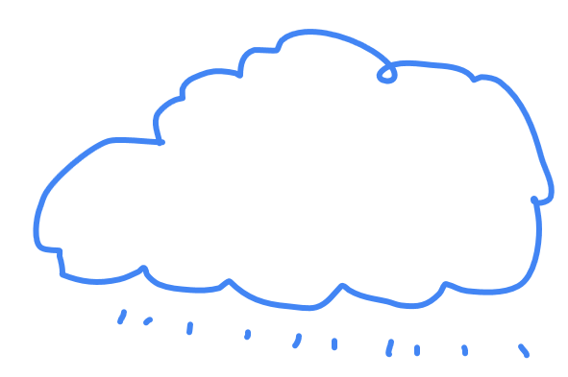 | 
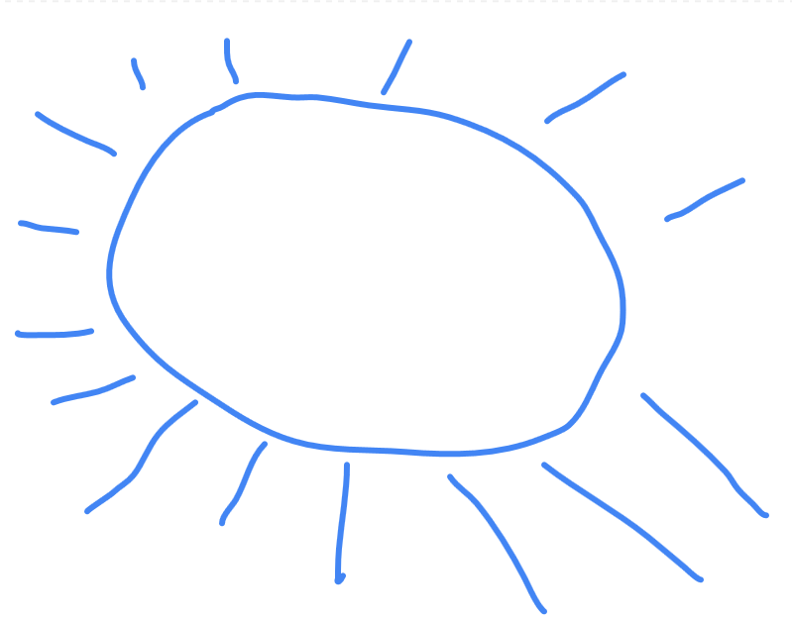 | 

Optional: You might also try out Quick, draw! Students will be given an object to draw in under 20 seconds. The AI will guess what it is, based on patterns of how people draw from all over the world. You can also refer to the data on which the AI has trained.
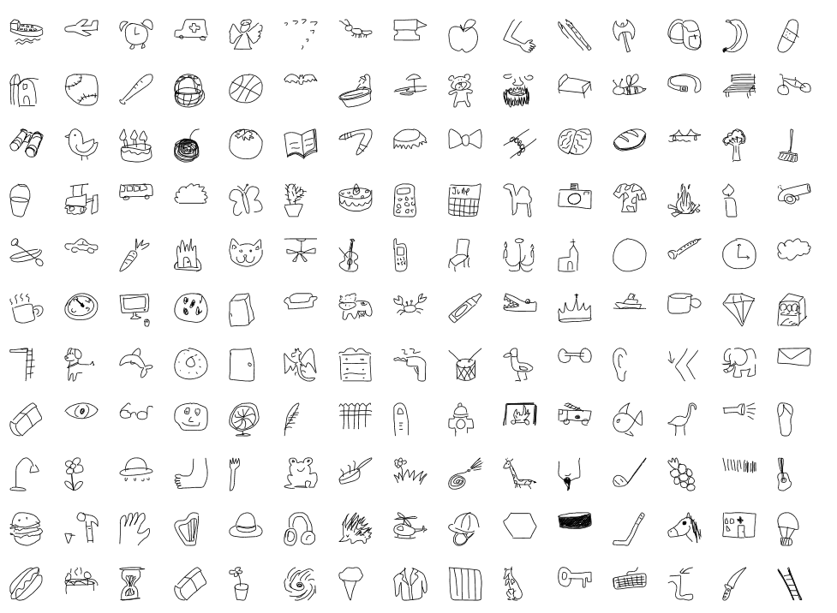
Image credit: Quick, Draw! The data

Discussion
- What did you learn about representing an object as a line drawing?
- How can you make sure that someone else can recognise what you are trying to draw?
- When is it important that a particular representation is easily recognised by everybody? Is this important in art?
- Share what you have learnt about AI and how ‘smart’ a computer can be.
- How well did the AI recognise what you were drawing?
- What was it good at recognising?
- When was the AI unsure or not correct? Why might this happen?

Why is this relevant?
When presenting data, for example, in a table we often use images to represent data together with numerical information. If collecting data about transport observed in our neighbourhood we might have a table with images of cars, bicycles, buses, trains and trucks together with numerical data (the number observed).
When we represent an idea or object as a picture we automatically draw on our understanding of the features of that particular thing. Think about how we would represent a car as opposed to a truck, or an ambulance as opposed to a van.
We use abstraction as we pick out only the relevant important information required. Finding just the right amount of abstraction can be challenging. If we abstract too much, we may leave out important information. If we abstract too little, we include unnecessary information.
AI is the ability of machines to mimic human capabilities in a way that we would consider 'smart'.
Machine learning is an application of AI. With machine learning, we give the machine lots of examples of data, demonstrating what we would like it to do so that it can figure out how to achieve a goal on its own. The machine learns and adapts its strategy to achieve the goal.
This lesson focuses on:
- data representation and abstraction
- feature extraction and image classification.

Resources

AI drawing experiment: AutoDraw
Optional AI drawing experiment: Quick, draw
Worksheet: Can an AI guess my drawing? PDF/ Word

Assessment

Teacher assessment
- Assess students on how well they can represent data as pictures, symbols and diagrams.
- Use formative assessment when students are creating their data representations.
Discuss the types of features that they are attempting to highlight.
The completed worksheet provides evidence of the student’s data representation skills.
- For summative assessment a suitable task is for students to create a visual chart that describes what they did on the weekend. Students can create their own representations that convey the message about the type of activity carried out during the weekend. Students think about their key activities and design an image that best represents each activity.
Share visual representations as a class and compare the ways common activities such as mealtimes, sleep, physical activity, watching TV or screen time, and visiting family are represented.
- An alternative assessment is for students to design a signpost showing directions to different animals at the zoo.

Australian Curriculum Alignment

Technologies – Digital Technologies
Years F–2
Represent data as pictures, symbols, numbers and words (AC9TDI2K02)

The Arts – Visual Arts
Share artworks and/or visual arts practice in informal settings (AC9AVA2P01 )
The Arts – Media Arts

Use media languages and media technologies to construct representations (AC9AMA2C01 )

ICT Capability
Typically, by the end of Year 2, students:
Generate solutions to challenges and learning area tasks
Experiment with ICT as a creative tool to generate simple solutions, modifications or data representations for particular audiences or purposes.
Collaborate, share and exchange
Use purposefully selected ICT tools safely to share and exchange information with appropriate local audiences.

Can an AI guess my drawing?

Name: _______________________________
My drawing | AI drawing

How well did the AI guess what you were drawing?
Colour in the stars. Five stars = AI was right all the time.


