Pixel art: practise with Tania Taylor’s turtle
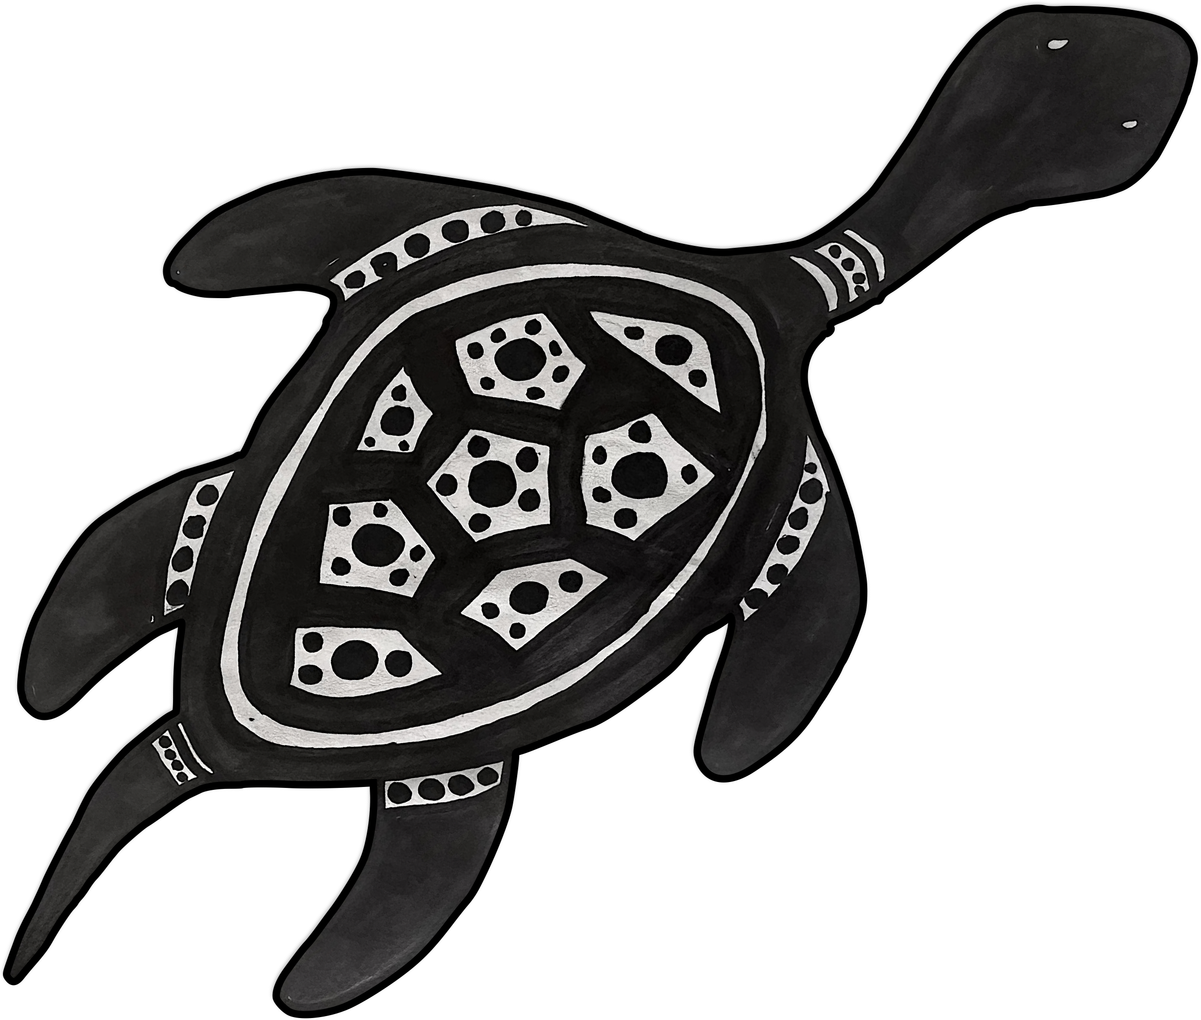
Use 1’s and 0’s to create a binary representation
of Tania Taylor’s turtle.
Then shade the zeros in black.

Turtle art © Tania Taylor

Turtle art by Tania Taylor ©

