Australian Curriculum:
Digital Technologies

Years 3–4
Sample assessment task
Classifying living or non-living things
Assessment focus: Australian Curriculum: Digital Technologies
(Data and Creating digital solutions)

About this assessment task
This sample assessment task has been prepared to assist teachers with the implementation of the Australian Curriculum: Digital Technologies, with a focus on data. It shows how aspects of the Digital Technologies curriculum related to data can be assessed using contexts from other learning areas and subjects. These contexts may be content that students have recently completed or are learning concurrently. This approach should enhance the manageability of the curriculum while still providing a targeted focus on Digital Technologies.
Purpose
The sample task aims to:
- demonstrate meaningful curriculum links to:
- Digital Technologies curriculum:
    - achievement standard
    - content descriptions
    - content strands
    - key concepts
    - key ideas (Technologies)
- general capabilities
- cross-curriculum priorities
- other learning areas. See Appendix 1 for specific links for this task.
- provide teacher support materials, suggested adjustments for students with diverse needs and resources. See Appendix 2.
- provide a template to create your own assessment task. See Appendix 3.
How to use this sample task
The sample task can be implemented as a standalone task or it can be used to inform planning of a:
- unit of work that might accompany the sample task
- similar task and/or unit of work with a focus on data.

Title: Classifying living or non-living things
Assessment focus: Australian Curriculum: Digital Technologies (Data and Creating digital solutions). This task is also linked to Science. Depending on modifications made to this task, opportunities may exist to link this task to Mathematics and/or English.
Band: Years 3 and 4 (intended cohort Year 3)
Context: Living or non-living things (Science)
Duration: Dependent on how the task is to be implemented
Prior learning: Students will have:
- learned about and created algorithms
- used Scratch
- created digital solutions and be aware of the steps involved
- completed activities to enable them to understand the difference between living, non-living and the products of living things; for example, viewing videos, discussions, sorting and classifying activities.

Task summary
Students will:
- collect data about living and non-living flora, fauna and objects in their playground
- classify their collection and explain their reasons for the classifications
- collate their data, for example tally marks, pictograph (100 ants = 1 large ant image)
- sort (order and organise) their data, for example in alpha or numeric order
- present the data in different ways:
- Venn diagram
- column graph
- pie chart
- infographic
- use their collated data to create a ‘living/non-living/product of living’ classifier using a visual programming language, such as Scratch. A classifier in this context is the algorithm (set of instructions) to model a classification system. Students will be able to:
- define the challenge
- identify the needs to be met by a classifier with teacher guidance
- collaborate to design and implement their classifier using input and branching features of a visual programming language. See sample in Resources section of Appendix 3.
- evaluate their classifier by explaining how it meets the identified needs.
The process will be documented using the structure of the Digital Technologies processes and production skills strand for Years 3 and 4: investigating and defining; producing and implementing; evaluating; collaborating and managing. Note: in Years 3 and 4 there is no content description for generating and designing.
Background information
Teacher guidance and support
Data sets do not need to be large for this activity. The number of insects and other items collected should not impact on student understanding of the difference between living, non-living and products of living things. Data interpretation and representation are the key focus. See Student task booklet.
Teachers should:
- do a risk assessment and give a safety briefing to students to ensure they are aware of the risks of living creatures (spiders, ants), products of living things (litter, sharp edges etc.) and understand safe distances
- provide a printed table or a soft copy for collection of data (see Student task booklet)
- provide supervision during playground data collation activity
- lead discussion on location of living, non-living and products of living things, and refer to school map to aid understanding of why creatures might be located in certain areas
- provide guidance for identifying a list of needs the classifier should meet
- provide guidance during design and implementation phase.
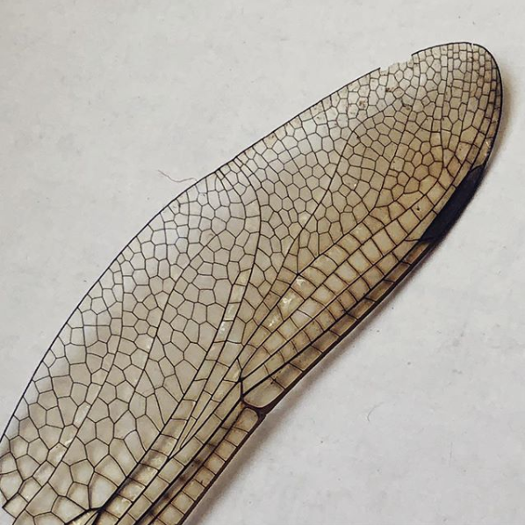 |  | 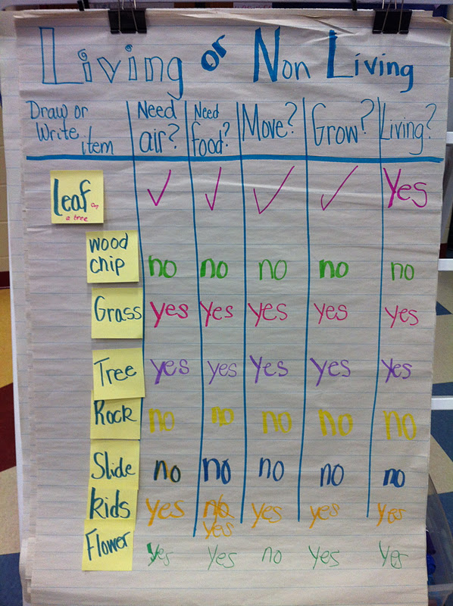
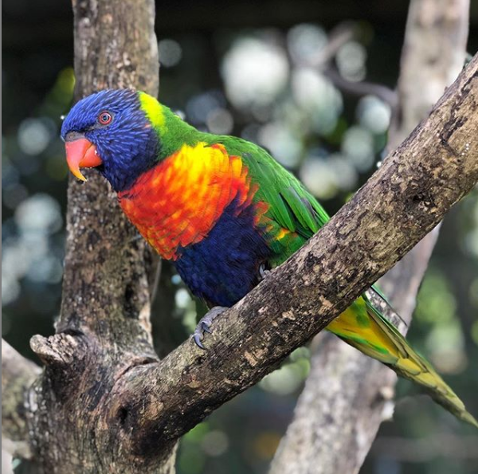 | 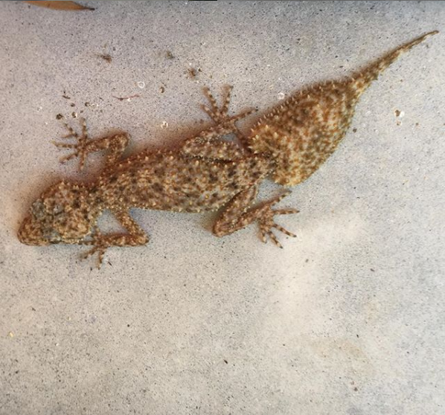
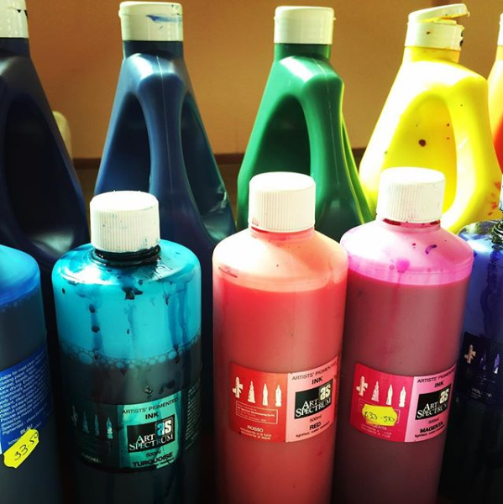 | 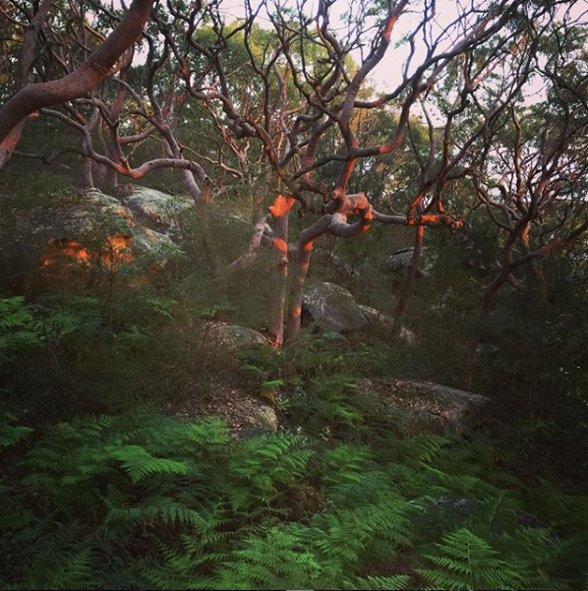 | 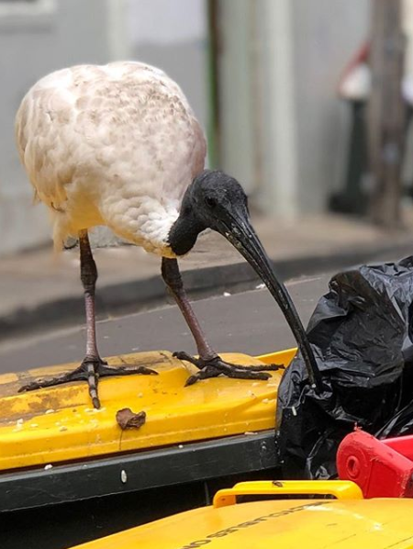 | 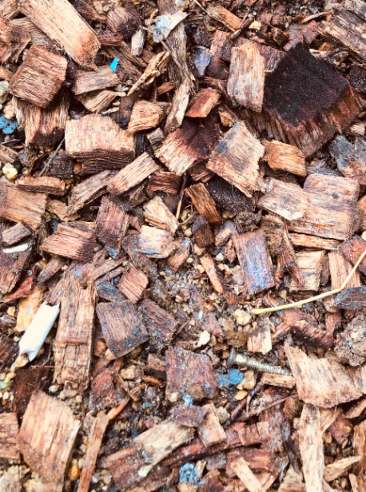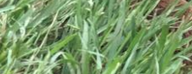
Links to the Australian Curriculum
Table 1 provides an opportunity for teachers to see all the related Australian Curriculum links to this task. For a more in-depth exploration of the links to the curriculum, see Appendix 1.
Table 1: Links from the task to the Australian Curriculum
Digital Technologies  Achievement standard  Aspects addressed by this task are highlighted. | By the end of Year 4, students describe how a range of digital systems (hardware and software) and their peripheral devices can be used for different purposes. They explain how the same data sets can be represented in different ways.  Students define simple problems, design and implement digital solutions using algorithms that involve decision-making and user input. They explain how the solutions meet their purposes. They collect and manipulate different data when creating information and digital solutions. They safely use and manage information systems for identified needs using agreed protocols and describe how information systems are used.
Strands | Digital Technologies knowledge and understanding  - Representation of data  Digital Technologies processes and production skills  - Collecting, managing and analysing data  - Creating designed solutions by  - Investigating and defining  - Producing and implementing  - Evaluating  - Collaborating and managing
Content descriptions | - Recognise different types of data and explore how the same data can be represented in different ways (ACTDIK008)  - Collect, access and present different types of data using simple software to create information and solve problems (ACTDIP009)  - Define simple problems, and describe and follow a sequence of steps and decisions (algorithms) needed to solve them (ACTDIP010)  - Implement simple digital solutions as visual programs with algorithms involving branching (decisions) and user input (ACTDIP011)  - Explain how student solutions and existing information systems meet common personal, school or community needs (ACTDIP012)  - Plan, create and communicate ideas and information independently and with others, applying agreed ethical and social protocols (ACTDIP013)
Key concepts | - data collection  - data representation  - data interpretation  - specification  - algorithms  - implementation  - interactions | Key ideas | - Thinking in Technologies  - Computational thinking  - Design thinking
Cross-curriculum priorities | N/A | General capabilities | - Information and Communication Technology (ICT) Capability  - Literacy  - Numeracy  - Ethical Understanding  - Personal and Social Capability
Assessment planner
Achievement standard  (relevant aspect of the achievement standard to be assessed) | Student evidence  (what student evidence will be considered to judge if the achievement standard aspect has been met)
Digital Technologies
They collect and manipulate different data when creating information and digital solutions. | - Records of data set observed in playground (photos, text)  - Infographic/Venn diagram/pie chart
They explain how the same data sets can be represented in different ways. | - Collated data using symbols/tallies to represent data  - Explanation of how methods/techniques used show how the same data can be represented differently
Students define simple problems, design and implement digital solutions using algorithms that involve decision-making and user input. | - Summary of what the digital solution should do; that is, assist user to classify living and non-living things  - A text or diagrammatic description (algorithm) of the steps and decisions that need to be made to create a solution that can classify things on the basis of criteria  - Digital solution (classifier program) that uses a visual programming language to classify things (living/non-living/products)
They explain how the solutions meet their purposes. | - Explanation (verbal/text/demonstration) of how the program classifies things

Assessment rubric
The rubric below shows only Digital Technologies. Note: There are opportunities to include Science, Literacy and Numeracy in the assessment.
Digital Technologies | Above standard  Students: | At standard  Students: | Below standard  Students:
Representation of data | use a variety of tools to classify data sets  justify why different data representations suit different contexts  define data requirements for their classifier including inputs, choices and possible variables for their classified items for their visual program | classify data sets  explain how the same data sets can be represented in different ways  define inputs and choices for their classified items in preparation for their visual program | classify data sets with support  demonstrate limited understanding of how the same data sets can be represented differently  define inputs and choices for their classified items with support
Collecting, managing and interpreting data | collect and manipulate different data independently when creating information and digital solutions | collect and manipulate different data when creating information and digital solutions | collect and manipulate different data when creating information and digital solutions with support
Investigating and defining | design a classifier program independently | design a classifier program with teacher guidance | design components of a classifier program with teacher guidance
Implementing | implement digital solutions by creating a classifier program using algorithms that involve decision-making, user input and variables using a visual programming language | implement digital solutions by creating a classifier program using algorithms that involve decision-making and user input using a visual programming language | attempt to implement limited digital solutions by creating a simplified classifier program using a visual programming language
Evaluating | evaluate their classifier and those of other students against identified needs  explain in detail how the classifier program meets the purpose  suggest improvements for the classifier | evaluate their classifier against identified needs  explain how the classifier program meets the purpose | evaluate their classifier against identified needs with support
Collaborating and managing | use and manage information systems safely and independently to create their classifier supporting their peers, where appropriate | use and manage information systems safely to create their classifier | safely use and manage information systems with support
Appendix 1
Australian Curriculum links (in detail)

Links to the Australian Curriculum
Digital Technologies
Achievement standard
By the end of Year 4, students describe how a range of digital systems (hardware and software) and their peripheral devices can be used for different purposes. They explain how the same data sets can be represented in different ways.
Students define simple problems, design and implement digital solutions using algorithms that involve decision-making and user input. They explain how the solutions meet their purposes. They collect and manipulate different data when creating information and digital solutions. They safely use and manage information systems for identified needs using agreed protocols and describe how information systems are used.
Content descriptions
Recognise different types of data and explore how the same data can be represented in different ways (ACTDIK008)
Collect, access and present different types of data using simple software to create information and solve problems (ACTDIP009)
Define simple problems, and describe and follow a sequence of steps and decisions (algorithms) needed to solve them (ACTDIP010)
Implement simple digital solutions as visual programs with algorithms involving branching (decisions) and user input (ACTDIP011)
Explain how student solutions and existing information systems meet common personal, school or community needs (ACTDIP012)
Plan, create and communicate ideas and information independently and with others, applying agreed ethical and social protocols (ACTDIP013)

Content strands
Digital Technologies knowledge and understanding |  | Digital Technologies processes and production skills
Digital systems |  | Collecting, managing and analysing data | X
Representation of data | X | Creating digital solutions by:
 |  | - investigating and defining | X
 |  | - generating and designing
 |  | - producing and implementing | X
 |  | - evaluating | X
 |  | - collaborating and managing | X

Links to the key ideas
Creating preferred futures | Students develop solutions to meet needs considering impacts on liveability, economic prosperity and environmental sustainability.
Project management | Students will develop skills to manage projects to successful completion through planning, organising and monitoring timelines, activities and the use of resources.
Thinking in Technologies
- Systems thinking | Systems thinking is a holistic approach to the identification and solving of problems where the focal points are treated as components of a system, and their interactions and interrelationships are analysed individually to see how they influence the functioning of the entire system.
- Design thinking | Design thinking involves the use of strategies for understanding design needs and opportunities, visualising and generating creative and innovative ideas, planning, and analysing and evaluating those ideas that best meet the criteria for success. | X
- Computational thinking | Computational thinking is a problem-solving method that is applied to create solutions that can be implemented using digital technologies. It involves integrating strategies, such as organising data logically, breaking down problems into parts, interpreting patterns and models and designing and implementing algorithms. | X
Read more about the key ideas in the Australian Curriculum: Technologies.

Links to the key concepts
The key concepts that underpin the Digital Technologies curriculum establish a way of thinking about problems, opportunities and information systems and provide a framework for knowledge and practice. (Colour coding is based on the Australian Computing Academy scheme.)
 | abstraction | underpins all content, particularly the content descriptions relating to the concepts of data representation; and specification; algorithms; and implementation
 | data collection | (properties, sources and collection of data) | X
 | data representation | (symbolism and separation)  - The same data are represented differently depending on their purpose.  - Data can be represented in many ways, for example photographs, tally marks. | X
 | data interpretation | (patterns and contexts)  - Data help us build understanding of key concepts from other curriculum areas.  - The way we present data helps us interpret them to create meaning. | X
 | specification | (descriptions and techniques)  - Students need to identify whether objects are living, non-living or product of living.  - With teacher guidance, students need to develop an understanding of the purpose of the classifier program.  - Students create questions that will be used in their classifier program, and understand the responses required. | X
 | algorithms | (following and describing)  - Students plan the steps needed for their classifier program using words and images.  - Students develop an understanding that branching involves following different steps based on a yes/no decision. | X
 | implementation | (translating and programming)  - Students build the classifier using visual programming that uses branching (decision-making) and needs user input. | X
 | digital systems | (hardware, software, and networks and the internet)
 | interactions | (people and digital systems, data and processes)
 | impact | (sustainability and empowerment)

Cross-curriculum priorities Read more…
Aboriginal and Torres Strait Islander histories and cultures | Asia and Australia’s engagement with Asia | Sustainability

General capabilities Read more…
Literacy | Numeracy | ICT Capability | Critical and Creative Thinking | Ethical Understanding | Personal and Social Capability | Intercultural Understanding
X | X | X |  | X | X
Links to ICT Capability continuum: Level 3
Depending on the year level this activity is being used with, adjust content to the appropriate level;
for example, Level 1a, 2.
Applying social and ethical protocols and practices when using ICT
acknowledge when they use digital products created by someone else, and start to indicate the source
independently apply standard guidelines and techniques for particular digital systems to secure digital information | X
apply standard guidelines and take action to avoid the common dangers to personal security when using ICT and apply appropriate basic social protocols when using ICT to communicate with unknown audiences
identify the value and role of ICT use at home and school
Investigating with ICT
use ICT to plan an information search or generation of information, recognising some pattern within the information | X
locate, retrieve or generate information from a range of digital sources | X
explain why located data or information was selected | X
Creating with ICT
use ICT to generate ideas and plan solutions | X
create and modify simple digital solutions, creative outputs or data representation/transformation for particular purposes | X
Communicating with ICT
use appropriate ICT tools safely to share and exchange information with appropriate known audiences
understand that computer mediated communications are directed to an audience for a purpose
Managing and operating ICT
identify and independently operate a range of devices, software, functions and commands, taking into consideration ergonomics when operating appropriate ICT systems, and seek solutions when encountering a problem | X
identify and compare the use of the main components of different ICT systems
manage and maintain digital data using common methods | X

Links to Literacy
In this Year 3 task in Digital Technologies, students have the opportunity to develop literacy by comprehending texts through listening, reading and viewing; composing texts through speaking, writing and creating; and using text, grammar, word and visual knowledge. They practise literacy skills as they navigate, read and review different text types; listen to instructions and to identify and respond to key information in spoken and multimodal texts; interpret, analyse, compose and edit learning area texts; and use language to interact with others. As students define problems, manipulate data, connect and express ideas, and give explanations, they apply their knowledge of text cohesion, grammar and spelling; and use subject-specific vocabulary. Students also identify how choices in visual elements create meaning.
Visit Literacy general capability https://www.australiancurriculum.edu.au/f-10-curriculum/general-capabilities/literacy/
Visit National Literacy Learning Progression https://www.australiancurriculum.edu.au/resources/national-literacy-and-numeracy-learning-progressions/national-literacy-learning-progression/
Links to Numeracy
In this Year 3 task in Digital Technologies, students have the opportunity to develop numeracy by estimating and calculating with whole numbers, recognising and using patterns and relationships, using spatial reasoning, and interpreting statistical information. In using software, materials, tools and equipment, students have opportunities to model, represent, order and use numbers in real-life situations; and to solve everyday addition and share stories. In implementing digital solutions, they collect and record data; identify and describe trends in everyday patterns; interpret information on diagrams; and display data as tables, diagrams and graphs. [91 words]
Visit Numeracy general capability https://www.australiancurriculum.edu.au/f-10-curriculum/general-capabilities/numeracy/
Visit National Numeracy Learning Progression
https://www.australiancurriculum.edu.au/resources/national-literacy-and-numeracy-learning-progressions/national-numeracy-learning-progression/

Links to the Science learning area
Science
Year 3 Science achievement standard
By the end of Year 3, students use their understanding of the movement of Earth, materials and the behaviour of heat to suggest explanations for everyday observations. They group living things based on observable features and distinguish them from non-living things. They describe how they can use science investigations to respond to questions.
Students use their experiences to identify questions and make predictions about scientific investigations. They follow procedures to collect and record observations and suggest possible reasons for their findings, based on patterns in their data. They describe how safety and fairness were considered and they use diagrams and other representations to communicate their ideas.
Suggested content – Science – living and non-living
Science understanding
- Living things can be grouped on the basis of observable features and can be distinguished from non-living things (ACSSU044)
- sorting living and non-living things based on characteristics
- exploring differences between living, once living and products of living things
Science as a human endeavour
- Science involves making predictions and describing patterns and relationships (ACSHE050)
Science inquiry skills
Questioning and predicting
- With guidance, identify questions in familiar contexts that can be investigated scientifically and make predictions based on prior knowledge (ACSIS053)
Processing and analysing data and information
- Use a range of methods including tables and simple column graphs to represent data and to identify patterns and trends (ACSIS057)
- Compare results with predictions, suggesting possible reasons for findings (ACSIS215)
Communicating
- Represent and communicate observations, ideas and findings using formal and informal representations (ACSIS060)

Appendix 2

Support materials

Things to think about
Rich questions and discussion starters
Students with diverse needs

Resources

Support materials

Things to think about
This task is about collecting and representing data. Consider the difference between 'represent' in Science (and Mathematics) and 'represent' in Digital Technologies.

Rich questions and discussion starters
Asking the right type of questions helps establish what students know about data and also what they can interpret from them. Use open-ended and probing questions (usually beginning with how, who, when, where and why) to promote critical thinking. For example:
- What patterns or themes emerge from the data?
- What proof exists for …?
- How would _____________ affect or influence ___________?
- How would you translate _______ into visual form?

See https://www.lavc.edu/profdev/library/docs/promotethink.aspx.

Students with diverse needs
Students may need simplified, scaffolded support materials. Adjustments to this task might include:
Data collection:
- Collecting data in your field of view from one static, pre-determined or pre-measured location.
- Focus on collecting data in a visual form such as in video, photographic, drawn or tally mark format.
Data representation and interpretation:
- Consider purpose of representation, for example people with low vision may need a physical representation such as using clapping or sound volume to convey amount of something.
- Use of concrete materials, for example 17 toothpicks might represent 17 ants.
Algorithms and implementation:
- Simplify the classification requirements and or allow for a classification scheme that might not be perfect, for example to determine if something is living, a good question might be ‘does it move?’ and an adequate response to determine a living or non-living object may be a simple yes or no.
- Demonstrate an understanding of the task through use of a simple, drawn flow chart instead of with a digital solution.

Students might need opportunities for extension. Adjustments for such students might include:
Data collection:
- After discussion with students, expand scope of data collected to include a wider variety of things that need further categorisation and sub-categorisation. For example, for non-living things such as rubbish, these may be then sub-categorised by manufactured/naturally occurring or recyclable/ non-recyclable. For living things, these might include several sub-types; for example, eggs, larvae, as well as juvenile and adult insects.
- Expand the times at which you observe or collect data which will change the type of living or non-living things that are found (variable). Certain birds may only be seen in the afternoon. Rubbish may appear only after school break times.
Data representation and interpretation:
- Students brainstorm and represent the same information in a range of different ways; for example, 17 ants might be represented by 1 giant ant which equals or measures 17 smaller ones.
- Represent total mass or physical properties of the items identified; for example, how can a representation be made when comparing size and weight of an ant and a tree?
- Brainstorm ways that people with diverse needs might experience these data; for example, how could this be represented to people with low vision? With hearing impairment?
Algorithms and implementation:
- Increase complexity requirements of the classification goals to reflect a wider and more sub-categorised data set that might reflect more detail about the living and non-living things; for example, dead ant/live ant, rubbish/rock.

Resources
- Sample classifier game using Scratch https://scratch.mit.edu/projects/288604818/
- Sample classifier game using Scratch (advanced) https://scratch.mit.edu/projects/288596012/
- Primary Connection Science Unit: Feather, Fur or Leaves http://www.scootle.edu.au/ec/viewing/S5686/pdf/Feathers_fur_or_leaves_online.pdf
- Living and non-living things Science Web Australia resource http://scienceweb.asta.edu.au/years-3-4/unit2/overview/yr34-unit2-overview.html
- Year 5 ACA Blockly Biology example (biology classifier) as input game with branching for living – non-living – products of living things https://aca.edu.au/resources/blockly-biology/
- F–2 lesson that can be adapted on becoming a data detective https://www.digitaltechnologieshub.edu.au/teachers/lesson-ideas/data-detective
- Sorting data in Years 3 and 4 lesson https://www.digitaltechnologieshub.edu.au/resourcedetail?id=d49e4898-09f9-6792-a599-ff0000f327dd#/
- An unplugged sorting activity https://classic.csunplugged.org/databases/
- Australian Computing Academy Key Concepts unpacked https://aca.edu.au/curriculum/3-4/
- The Digital Technologies Hub https://www.digitaltechnologieshub.edu.au/ has a number of resources to support assessment and reporting of the Digital Technologies curriculum. These include:
- Assessing in Digital Technologies webinar: https://www.digitaltechnologieshub.edu.au/teachers/professional-learning/webinars/assessment-for-digital-technologies
- Webinar handout https://www.digitaltechnologieshub.edu.au/docs/default-source/webinar-slides-and-handouts/dt-hub-webinar-19_assessment_handout.pdf
- Planning for assessment https://www.digitaltechnologieshub.edu.au/teachers/assessment/planning-for-assessment
- Unpacking assessment https://www.digitaltechnologieshub.edu.au/teachers/assessment/unpacking-assessment
A series of video presentations by Dr Rebecca Vivian with discussions including formative and summative assessment opportunities and rationale.
- A demonstration of building skills in critiquing – looking with the eyes of a scientist. Ron Berger critiquing example https://youtu.be/hqh1MRWZjms
- Create your own assessment task rubric https://www.digitaltechnologieshub.edu.au/docs/default-source/webinar-slides-and-handouts/dt-hub-webinar-19_assessment_assessment-3-0.pdf

Appendix 3

Data task planning template
This template is a suggested step-by-step approach that teachers might use to consider whether all or any of these links apply to an assessment task they develop themselves to better reflect the learning needs of their students and the context of their classroom and school.

Planning template suggested approach
Below is a broad outline of how to use the assessment task planning template on the following pages. It reflects the work of Wiggins and McTighe (2012) on Understanding by Design, which features a backward design approach.

- Begin with Digital Technologies:
  - determine the aspects of the achievement standard that will be the focus of the task
  - highlight the relevant aspects of the standard
  - identify what knowledge and skills students will need in order to demonstrate the achievement standards (content descriptions)
  - identify the strands and threads that will need to be addressed.
- As Digital Technologies is the driving learning area, it is suggested that only the key ideas for this learning area be identified.
- Indicate the key concepts of Digital Technologies that will be addressed and how.
- Scan the Australian Curriculum to find meaningful connections between:
  - learning areas (two learning areas helps keep learning focused; avoid more than three)
  - general capabilities
  - cross-curriculum priorities.
For example, connections could be established on the grounds of:
  - common concepts/key ideas, such as data/design/ways of thinking
  - common words, such as ‘create’, ‘communicate’ and ‘control’
  - contexts, from learning areas such as Science, HASS, HPE, The Arts.
- Indicate what general capabilities and cross-curriculum priorities can be meaningfully addressed in the assessment task.
- Construct a task that allows for discrimination in performance and includes:
  - title
  - band level
  - duration
  - task summary, including prior learning
  - achievement standards and content descriptions
  - task
  - assessment rubric.
Search for xxxx and replace with your own text.
Title: xxxx
Assessment focus: Australian Curriculum: Digital Technologies
(Data and Creating digital solutions). This task is also linked to xxxx. Depending on modifications made to this task, opportunities may exist to link this task to xxxx and/or xxxx.
Band: Years 3 and 4 (intended cohort Year x)
Context: xxxx
Duration: xxxx
Prior learning: Students will have:
- learned about and created algorithms
- used Scratch
- created digital solutions and be aware of the steps involved
- completed activities to enable them to understand xxxx. For example, xxxx.

Task summary
Students will:
- collect data about xxxx
- classify their collection and explain their reasons for the classifications
- collate their data, for example tally marks, pictograph (100 ants = 1 large ant image)
- sort (order and organise) their data, for example in alpha or numeric order
- present the data in different ways:
- Venn diagram
- column graph
- pie chart
- infographic
- use their collated data to create a ‘xxxx’ classifier using a visual programming language, such as Scratch. Students will be able to:
- define the challenge
- identify the needs that need to be met by a classifier with teacher guidance
- collaborate to design and implement their classifier using input and branching features of a visual programming language. See sample in Resources section of Appendix 3.
- evaluate their classifier by explaining how it meets the identified needs.
The process will be documented using the structure of the Digital Technologies processes and production skills strand for Years 3 and 4: investigating and defining; producing and implementing; evaluating; collaborating and managing. Note: in Years 3 and 4 there is no content description for generating and designing.

Digital Technologies
Achievement standard
By the end of Year 4, students describe how a range of digital systems (hardware and software) and their peripheral devices can be used for different purposes. They explain how the same data sets can be represented in different ways.
Students define simple problems, design and implement digital solutions using algorithms that involve decision-making and user input. They explain how the solutions meet their purposes. They collect and manipulate different data when creating information and digital solutions. They safely use and manage information systems for identified needs using agreed protocols and describe how information systems are used.
Content descriptions
Recognise different types of data and explore how the same data can be represented in different ways (ACTDIK008)
Collect, access and present different types of data using simple software to create information and solve problems (ACTDIP009)
Define simple problems, and describe and follow a sequence of steps and decisions (algorithms) needed to solve them (ACTDIP010)
Implement simple digital solutions as visual programs with algorithms involving branching (decisions) and user input (ACTDIP011)
Explain how student solutions and existing information systems meet common personal, school or community needs (ACTDIP012)
Plan, create and communicate ideas and information independently and with others, applying agreed ethical and social protocols (ACTDIP013)

Content strands [X any that apply]
Digital Technologies knowledge and understanding |  | Digital Technologies processes and production skills
Digital systems  Representation of data |  | Collecting, managing and analysing data  Creating digital solutions by:  - investigating and defining  - generating and designing  - producing and implementing  - evaluating  - collaborating and managing

Links to the key ideas [X any that apply]
Read more about the key ideas in the Australian Curriculum: Technologies.

Creating preferred futures | Students develop solutions to meet needs considering impacts on liveability, economic prosperity and environmental sustainability.
Project management | Students will develop skills to manage projects to successful completion through planning, organising and monitoring timelines, activities and the use of resources.
Thinking in Technologies
- Systems thinking | Systems thinking is a holistic approach to the identification and solving of problems where the focal points are treated as components of a system, and their interactions and interrelationships are analysed individually to see how they influence the functioning of the entire system.
- Design thinking | Design thinking involves the use of strategies for understanding design needs and opportunities, visualising and generating creative and innovative ideas, planning, and analysing and evaluating those ideas that best meet the criteria for success.
- Computational thinking | Computational thinking is a problem-solving method that is applied to create solutions that can be implemented using digital technologies. It involves integrating strategies, such as organising data logically, breaking down problems into parts, interpreting patterns and models and designing and implementing algorithms.

Links to the key concepts
[X any that apply and insert ideas about how they could be addressed]
The key concepts that underpin the Digital Technologies curriculum establish a way of thinking
about problems, opportunities and information systems and provide a framework for knowledge
and practice. (Colour coding is based on the Australian Computing Academy scheme.)
 | abstraction | underpins all content, particularly the content descriptions relating to the concepts of data representation; and specification; algorithms; and implementation
 | data collection | (properties, sources and collection of data)
 | data representation | (symbolism and separation)
 | data interpretation | (patterns and contexts)
 | specification | (descriptions and techniques)
 | algorithms | (following and describing)
 | implementation | (translating and programming)
 | digital systems | (hardware, software, and networks and the internet)
 | interactions | (people and digital systems, data and processes)
 | impact | (sustainability and empowerment)
Cross-curriculum priorities [X any that apply] Read more…
Aboriginal and Torres Strait Islander histories and cultures | Asia and Australia’s engagement with Asia | Sustainability

General capabilities [X any that apply] Read more…
Literacy | Numeracy | ICT Capability | Critical and Creative Thinking | Ethical Understanding | Personal and Social Capability | Intercultural Understanding

Links to ICT Capability continuum: Level [ insert ] [X any that apply] Read more…
Depending on the year level this activity is being used with, adjust content to the appropriate level.
Applying social and ethical protocols and practices when using ICT
acknowledge when they use digital products created by someone else, and start to indicate the source
independently apply standard guidelines and techniques for particular digital systems to secure digital information
apply standard guidelines and take action to avoid the common dangers to personal security when using ICT and apply appropriate basic social protocols when using ICT to communicate with unknown audiences
identify the value and role of ICT use at home and school
Investigating with ICT
use ICT to plan an information search or generation of information, recognising some pattern within the information
locate, retrieve or generate information from a range of digital sources
explain why located data or information was selected
Creating with ICT
use ICT to generate ideas and plan solutions
create and modify simple digital solutions, creative outputs or data representation/transformation for particular purposes
Communicating with ICT
use appropriate ICT tools safely to share and exchange information with appropriate known audiences
understand that computer mediated communications are directed to an audience for a purpose
Managing and operating ICT
identify and independently operate a range of devices, software, functions and commands, taking into consideration ergonomics when operating appropriate ICT systems, and seek solutions when encountering a problem
identify and compare the use of the main components of different ICT systems
manage and maintain digital data using common methods
Links to Literacy and Numeracy
Depending on the year level this activity is being used with adjust content to appropriate level.
xxxx

