Introduction to Action Script 3

Stop Command
In most games you create, you will want the Movie to stop on frame 1 so that it can execute the code or wait for player input (such as inputting a name or clicking a Play button).
You will need to use a stop command to do this.
On frame 1 of the first scene in your movie right click and choose Actions (or click on F9). This will bring up the Actions Panel.
Type stop(); into line 1 as shown below.
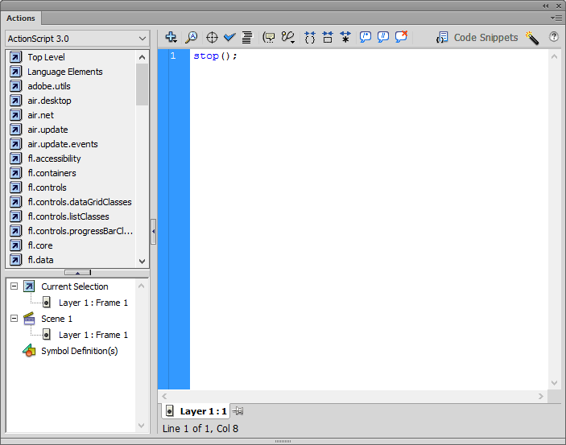
Close the Actions window.

Trace Command
The trace command outputs information into a special window called the Output Window. The trace command is one of the many tools that you use to find bugs in your program. The syntax for the trace command is as follows:
trace();
Example: trace(“Hello World”);

Activity 1:
Open up Flash and create a new Action Script 3.0 movie project.
Right-click on the first frame on the first layer; a pop-up menu will appear.
Select Actions from the menu to access the Actions Panel (alternatively, press F9 on the keyboard).

Type in the trace command as so: trace(“My first ActionScript program”);
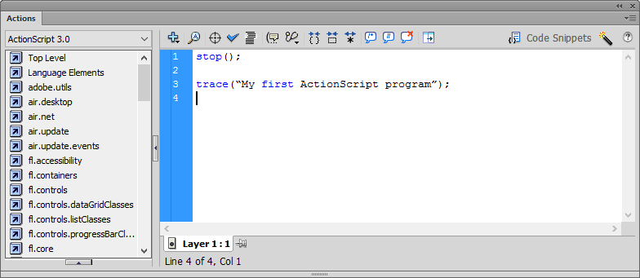
Close the Actions Panel.
Save the file as trace.fla
Test the movie by clicking on the Control Menu – Test Movie – test in Flash Professional.
You should get an Output window as shown below.
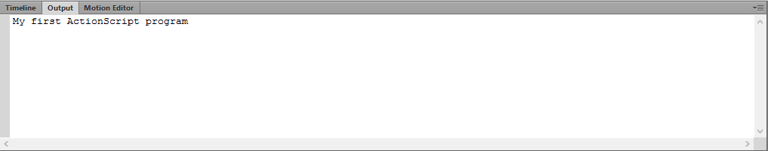

Comments
ActionScript allows you to type in reminders, notes and comments for yourself right in the program. Comments are like little notes to yourself – or to whomever has to read your code six months down the line. They can help explain complex pieces of code, and they often help you remember what you were trying to do with that logic. The syntax to a comment is similar to other languages (such as Java). When you start a line with a double forward slash (//), you’re allowed to write anything you want on the same line and it will not affect the running of the code. Try to comment on any code that you had to stop and think about before writing. This may help you to understand your code later on.
Go back to your trace command and add a comment above it as shown:
// The trace function displays text to the output window
trace(“My first ActionScript program”);
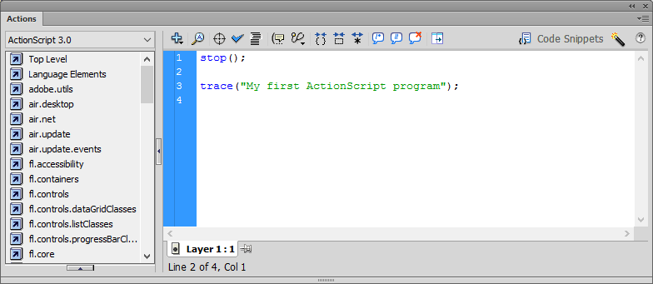

Variables
Variables are the very core of any programming language. The commands of the language manipulate the data and this data happens to be stored in these variables.
When declaring a variable in ActionScript 3, you must use the keyword var. Right after the var keyword you type the name of the variable you want to use followed by a colon and the type of variable it will be ie String, integer, double etc.
Examples of local variables:
var numApples:int = 4;
var guestName:String = “John”;
var livesLeft:int = 3;

Activity 2:
Add the following code under your trace function.
var myVar:String = “This is my first variable”;
trace(myVar);
Your output should look like the following:
