Binary Acknowledgement of Country
Please refer to the online lesson plan on the DT Hub to access all website links and additional resources.

Year levels: 5–6

Digital Technologies: Data representation
Duration: 2 x 60 min

In this learning sequence we explore data representation, learning about the way data in the form of text can be represented in binary (on and off states). In using the context of Acknowledgement of Country, we explore First Nations Australian language or group names written digitally as symbols and using a long thread of beads.

Learning map and outcomes
- Identify the local First Nations Australian language or language group(s).
- Describe how text can be represented in binary.
- Represent the local First Nations Australian language or language group(s) in binary (on and off states).

Preparation
Slides: Entry and exit tickets
Slides: Binary Acknowledgement of Country
Read: Teacher background information on Acknowledgement of Country
Provide handouts: Student worksheet: Binary challenge

Learning hook
Use Slide 2 of Entry and exit tickets to engage student interest and curiosity.
Share ideas as a class as to what the sequence of black and white squares represent.
Note: At the end of the session students come back to the problem and use their new knowledge to answer the question (exit ticket).

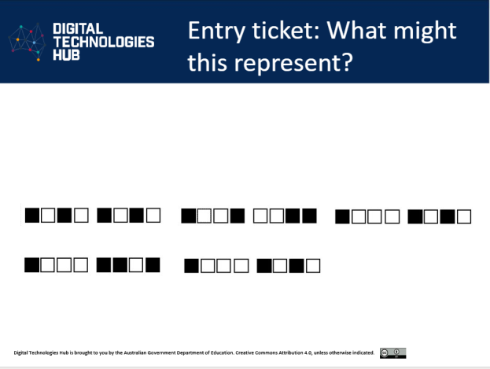
Entry and exit tickets, Slide 2

Use the slides Binary Acknowledgement of Country to introduce the lesson. Refer to Slide 1.
Ask students what they notice and wonder. Use the slide notes to prompt and direct thinking.
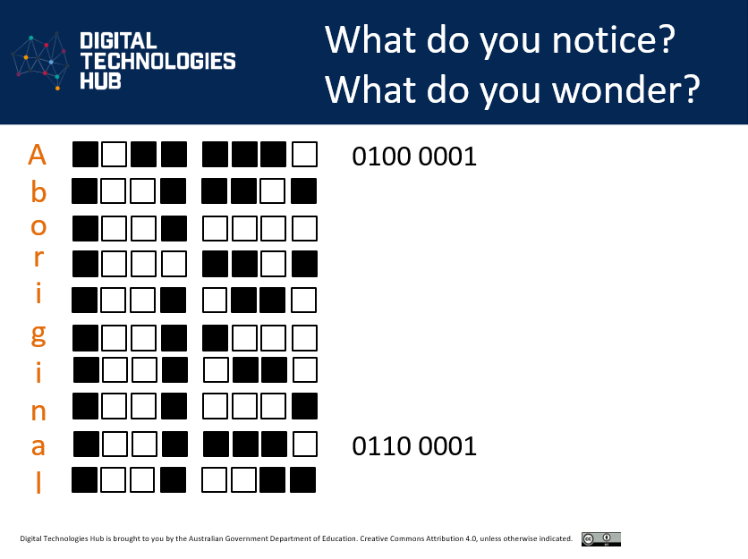
Binary Acknowledgement of Country, Slide 2

Learning input and construction
Point out, if not noticed by students, that the binary number of ‘A’ is 0100 0001 and that ‘a’ is represented by 0110 0001. Discuss reasons why these might need to be different. Make explicit that each letter has a lower case and a capital letter representation. Explain that this use of binary numbers is the way digital systems such as computers store and transmit data.

Make the cultural connection of using capitalised letters as a form of respect; for example, when using the terms: Aboriginal and Torres Strait Islander Peoples, First Nations Australian, Traditional Owners and Custodians.

Use slides 3 and 4 to match three binary numbers on the slide to the correct letter. Students use the combination of black and white squares represented in a sequence of 8 squares to match to the correct binary number. Check their understanding.

Provide the student handout: Binary challenge. Ask the students to choose a word to represent in binary. Students may choose to represent the on and off states shading in the relevant squares, and they may also write the corresponding binary number.

Differentiation
Students may choose a word with a few letters, words with more letters, or more than one word.
Enabling prompts: What letter representations are already included on the sheet to help you represent your chosen word in binary?
Extending prompts:
- How can you work out the binary number for a letter?
- What patterns do you notice between a capital letter and its lower-case counterpart?

Learning input
Use slides 5–6. Identify and acknowledge the Traditional Owners and Custodians of the lands on which the school sits, referring to your school’s Acknowledgement of Country, and introduce the learning task.

Incorporate into this lesson finding out about the Traditional Owners and Custodians and the local language or language group(s) on which your school sits. Spellings vary or may change over time; refer to the suggested resources.

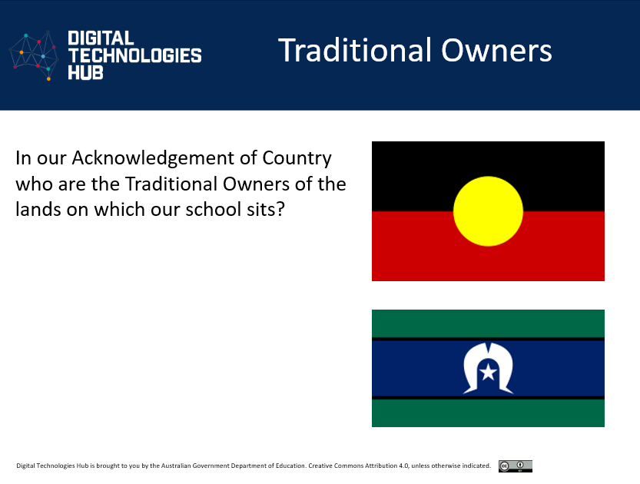
Binary Acknowledgement of Country, Slide 5

Identify the Traditional Owners and Custodians and the local language or language group(s). Write these out. Ask students to use the binary alphabet chart in the slides 13–16 to work out the binary representation.

Differentiation
The task can be divided up so that pairs of students represent a letter of the Traditional Owners and Custodians or local language or language group.
You may choose to collaboratively work as a class to make a long thread with beads representing letters that spell each letter of the Traditional Owners and Custodians. This sequence of beads can be displayed as a binary banner as part of the Acknowledgement of Country inserting the name of the Peoples in the relevant part of the acknowledgement.

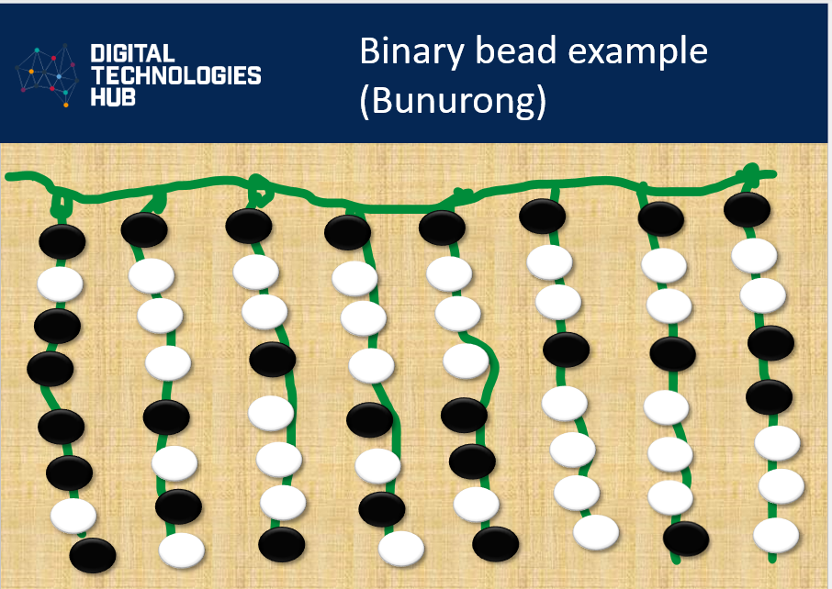
Binary Acknowledgement of Country, Slide 7

Why is this relevant?
Students can explore ways in which many First Nations Australians are embracing digital tools to maintain, control, protect and further develop cultures through the digitisation of cultural expressions. This lesson also provides the opportunity to make connections to First Nations Australians’ use of verbal and non-verbal binary systems.

Assessment
Achievement standard
By the end of Year 6, students process data and show how digital systems represent data.

Exit ticket: Refer back to the entry ticket problem. Have students respond with what they now know the sequence of black and white squares to represent.
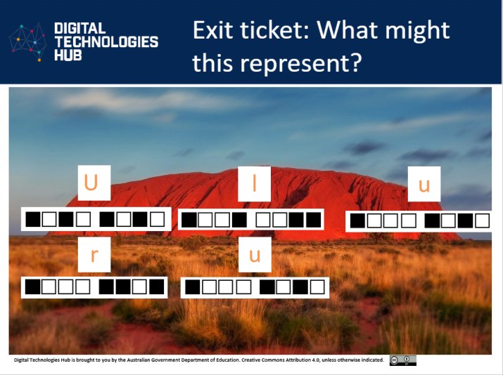
Entry and exit tickets: Slide 9 (final slide)

Differentiation: To reduce cognitive load some students may choose to decode one binary representation identifying a single letter.

Australian Curriculum alignment
Technologies – Digital Technologies, Years 5–6
- Explore how data can be represented by off and on states (zeros and ones in binary) AC9TDI6K04

Cross-curriculum priorities
Aboriginal and Torres Strait Islander Histories and Cultures
Country/Place
- First Nations communities of Australia maintain a deep connection to, and responsibility for, Country/Place and have holistic values and belief systems that are connected to the land, sea, sky and waterways. A_TSICP1

Culture
- First Nations Australian societies are diverse and have distinct cultural expressions such as language, customs and beliefs. As First Nations Peoples of Australia, they have the right to maintain, control, protect and develop their cultural expressions, while also maintaining the right to control, protect and develop culture as Indigenous Cultural and Intellectual Property. A_TSIC1

Resources
Teacher background information: Use this resource to support teacher understanding and possibly deepen knowledge about Acknowledgement of Country and the opportunities to recognise Australian First Nations Peoples’ special connection, physically and spiritually, to Country/Place.

Use these and similar resources to find out more about your local First Nations language group(s).
- Victorian Aboriginal Corporation for Languages
- Acknowledgement of Traditional Owners (Victoria)
- Tasmanian Aboriginal Centre: palawa kani, the only Aboriginal language in lutruwita today
- The Aboriginal Education Consultative Group (AECG) in New South Wales and has developed the NSW AECG Languages App which can be accessed via: https://www.aecg.nsw.edu.au/download-aecg-languages-app/
- Explore this map from the Australian Institute of Aboriginal and Torres Strait Islander Studies website: https://aiatsis.gov.au/explore/map-indigenous-australia
- The Welcome to Country app (Apple only) can help with identifying local or regional languages: https://apps.apple.com/us/app/welcome-to-country/id1005047597

